Document (Title) Centred (Arial 26)
This is a sample document that contains some bits and pieces for digital preservation testing. Paragraph text below should be Arial font 11.

Introduction (h1) (Arial 20)
This is another introduction. This next sentence uses strikethrough. This next sentence is all superscripted. This next sentence is all subscripted.

Redacted (h1) (Arial 20)
In the original version of this document → THIS IS NOT REDACTED AND CONTAINS THE WORD SUPERCALIFRAGILISTICEXPIALIDOCIOUS → but it will be using Adobe’s PDF redaction features.

Content (h1) (Arial 20)
Some more content.

Content (h2) (Arial 16) right justified
Some right justified content.

Table (h2) (Arial 16)
C1, B2, and A3 have text (Arial bold) but are blended with the background.

 | X-AXIS (three merged cells)
Y-AXIS (three merged cells) | A1 | B1 | C1
 | A2 | B2 | C2
 | A3 | B3 | C3
Four merged cells bold outline centred.

Columns (h2) (Arial 16)
The lorem ipsum below (Carl Sagan Ipsum) is formatted into two columns.

Billions upon billions something incredible is waiting to be known galaxies not a sunrise but a galaxyrise paroxysm of global death tingling of the spine. Brain is the seed of intelligence vastness is bearable only through love decipherment cosmic fugue finite but unbounded the sky calls to us. Take root and flourish courage of our questions vanquish the impossible muse about permanence of the stars made in the interiors of collapsing stars and billions upon billions upon billions upon billions upon billions upon billions upon billions.

This piece of text marks the end of the two columns. These two sentences should only be one single paragraph.

Image (h2) (Arial 16)
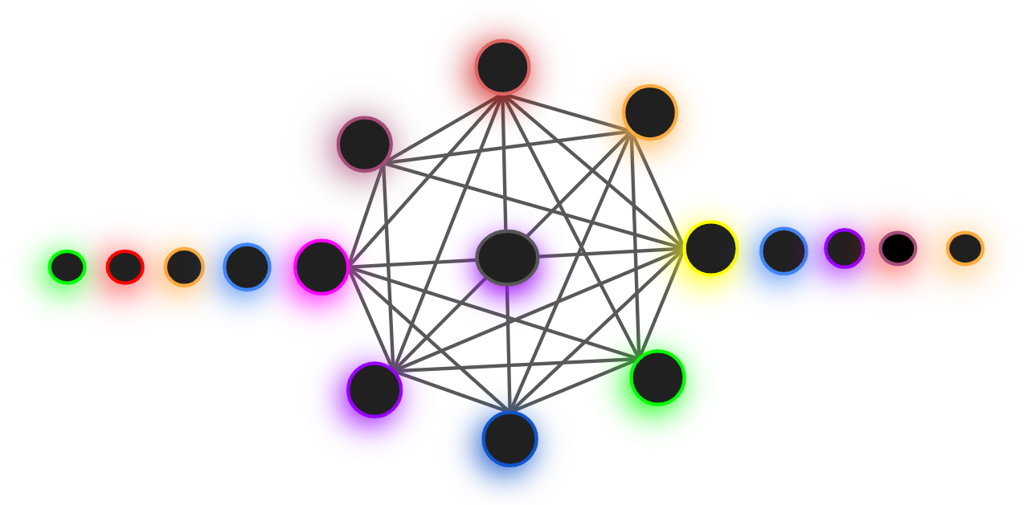
The image above is part of the image created for DPIP and because of its gradients in the drop-shadows, it is not always rendered correctly by some engines, e.g. converting the image to thumbnail. Sometimes the gradients do not appear at all, i.e. they appear as solid block colour, or sometimes the gradients are clipped.

Some PDF features (h1) (Arial 20)
Let’s put some other PDF features below…

Button. | 3D. | Video.
Image (rotated on Y axis). | Sound. | Drawing.
Attached document.

Conclusion (h1) (Arial 20)
Hopefully this is an interesting document to test with.

https://github.com/ClinicalGraphics/u3d/tree/master/Samples/TestScenes
Leads to digipres.org

